30289297 PJA VAN ZYL

Create database BidvestBank

Use database BidvestBank

CREATE TABLE BankBranch

(

branch_name VARCHAR(50) NOT NULL PRIMARY KEY,

branch_city VARCHAR(50)NOT NULL,

assets int(10) NOT NULL

);

CREATE TABLE Customeraccount

(

account_number CHAR(6) NOT NULL PRIMARY KEY,

branch_name NVARCHAR(50)NOT NULL,

Balance Decimal NOT NULL

);

CREATE TABLE Customer

(

customer_name NVARCHAR(50) NOT NULL,

customer_street NVARCHAR(50) NOT NULL,

customer_city NVARCHAR(50) NOT NULL,

primary key (customer_name, customer_street )

);

CREATE TABLE Loan

(

loan_number CHAR(5) NOT NULL PRIMARY KEY,

branch_name NVARCHAR(50) NOT NULL,

amount DECIMAL NOT NULL );

CREATE TABLE Depositor

(

customer_name NVARCHAR(50) NOT NULL,

account_number CHAR(6) NOT NULL,

Primary key (account_number)

);

CREATE TABLE Borrower

(

customer_name NVARCHAR(50) NOT NULL,

loan_number CHAR(5) NOT NULL,

Primary key (loan_number,customer_name)

);

CREATE TABLE Employee

(

Employee_name VARCHAR(50) NOT NULL PRIMARY KEY,

branch_name NVARCHAR(50) NOT NULL,

salary DECIMAL NOT NULL

);

insert into CustomerAccount values('A-5324', 'Newtown', 500);

insert into CustomerAccount values('A-5624', 'Sunnyside', 400);

insert into CustomerAccount values('A-7794', 'Midrand', 900);

insert into CustomerAccount values ('A-4467', 'Mabopane', 700);

insert into CustomerAccount values('A-3546', 'Midrand', 750);

insert into CustomerAccount values ('A-3453', 'Universitas', 700);

insert into CustomerAccount values('A-2542', 'Mamelodi', 350);

insert into BankBranch values('Midrand', 'Johannesburg', 7100000);

insert into BankBranch values('Newtown', 'Johannesburg', 9000000);

insert into BankBranch values('Mabopane', 'Pretoria', 400000);

insert into BankBranch values('Belgravia', 'Kimberly', 3700000);

insert into BankBranch values('Sunnyside', 'Pretoria', 1700000);

insert into BankBranch values('Amanzimtoti', 'Durban', 300000);

insert into BankBranch values('Universitas', 'Bloemfontein', 2100000);

insert into BankBranch values('Mamelodi', 'Pretoria', 8000000);

insert into customer values('Modise', 'Spring', 'George');

insert into customer values('Brooks', 'Senator', 'Johannesburg');

insert into customer values('Jooste', 'North', 'Kimberly');

insert into customer values('Lombard', 'Sand Hill', 'Nelspruit');

insert into customer values('Mokwena', 'Walnut', 'Port-Elizabeth');

insert into customer values('Johnson', 'Mmabatho', 'Mafikeng');

insert into customer values('deleJohnson', 'Alma', 'Bloemfontein');

insert into customer values('Zwane', 'Main', 'Mafikeng');

insert into customer values('Lindsay', 'Park', 'George');

insert into customer values('Smith', 'North', 'Kimberly');

insert into customer values('Dlamini', 'Putnam', 'Port-Elizabeth');

insert into customer values('Williams', 'Nassau', 'Giyane');

insert into depositor values('Johnson', 'A-5624');

insert into depositor values('Johnson', 'A-5624');

insert into depositor values('Johnson', 'A-7794');

insert into depositor values('Zwane', 'A-3546');

insert into depositor values('Lindsay', 'A-3453');

insert into depositor values('Smith', 'A-4467');

insert into depositor values('Dlamini', 'A-2542');

insert into loan values('L-11', 'Mamelodi', 900);

insert into loan values('L-14', 'Newtown', 1500);

insert into loan values('L-15', 'Sunnyside', 1500);

insert into loan values('L-16', 'Sunnyside', 1300);

insert into loan values('L-17', 'Newtown', 1000);

insert into loan values('L-23', 'Universitas', 2000);

insert into loan values('L-93', 'Mabopane', 500);

insert into borrower values('Modise', 'L-16');

insert into borrower values('Jooste', 'L-93');

insert into borrower values('Johnson', 'L-15');

insert into borrower values('Jackson', 'L-14');

insert into borrower values('Zwane', 'L-17');

insert into borrower values('Smith', 'L-11');

insert into borrower values('Smith', 'L-23');

insert into borrower values('Williams', 'L-17');

insert into employee values('Modise', 'Sunnyside', 1500);

insert into employee values('Brown', 'Sunnyside', 1300);

insert into employee values('Gopal', 'Sunnyside', 5300);

insert into employee values('Johnson', 'Newtown', 1500);

insert into employee values('Loreena', 'Newtown', 1300);

insert into employee values('Peterson', 'Newtown', 2500);

insert into employee values('Rao', 'Austin', 1500);

insert into employee values('Sato', 'Austin', 1600);

4.

I)

Select * from customeraccount where balance > 700;

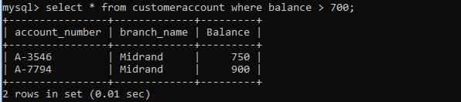

II)

Select customer_name from customer where customer_city = 'Johannesburg';



III)

Select * from employee where salary > 1500 and branch_name <> 'Newtown';

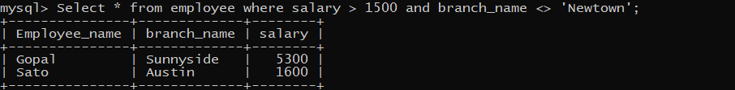

IV)

SELECT AVG(salary) AS avg_salary FROM employee;

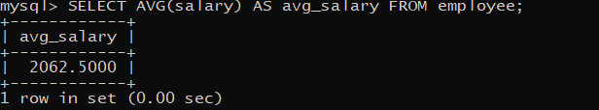

V)

Select * from BankBranch where assets = (select max(assets) from bankbranch);

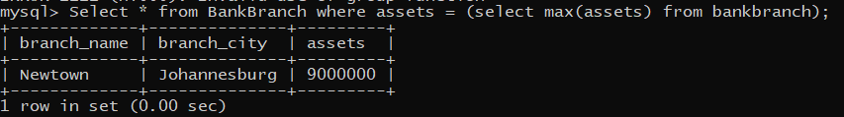

5.

I)

Select * from employee where branch_name = 'Sunnyside';

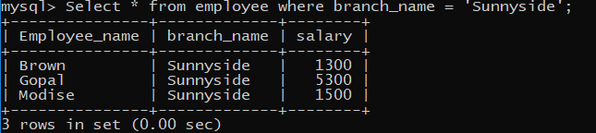

II)

Select * from borrower;

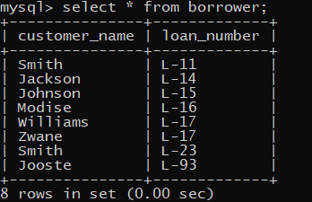

III)

Select account_number from customeraccount where balance < 900;

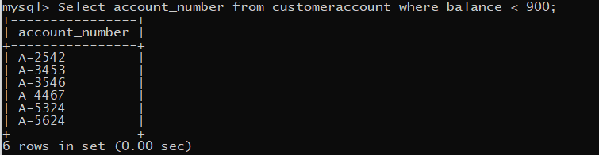

IV)

Select account_number from customeraccount where balance < 600 and branch_name = 'Newtown';

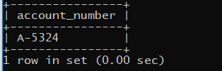

V)

Select branch_name, assets from bankbranch;

